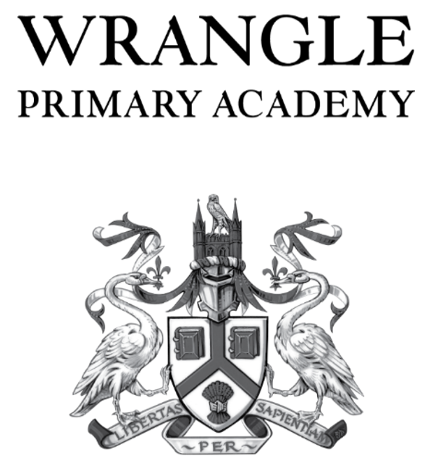

RSE Parent Carer Consultation Response Form

- I think RSE/PSHE education is an important part of our academy curriculum.
Please mark one circle
- Strongly Agree
- Agree
- Neutral
- Disagree
- Strongly disagree

- I think RSE / PSHE topics are taught in the academy can make a real difference to children’s lives.
Please mark one circle
- Strongly Agree
- Agree
- Neutral
- Disagree
- Strongly disagree

- I feel happy to talk to my child about growing up and relationships.
Please mark one circle
- Strongly Agree
- Agree
- Neutral
- Disagree
- Strongly disagree

- I feel happy with the content of the RSE/PSHE policy
Please mark one circle
- Strongly Agree
- Agree
- Neutral
- Disagree
- Strongly disagree

- I am aware of the topics that will be covered in the RSE / PSHE sessions at Wrangle Primary Academy.
- Yes
- No
- I would like more information and will therefore be attending the information session

- Are there any other comments that you would like to make about the RSE / PSHE provision at Wrangle Primary Academy?
- Yes
- No

- Comments

________________________________________________________________________________________________________________________________________________________________________________________________________________________________________________________________________________________________________________________________________

