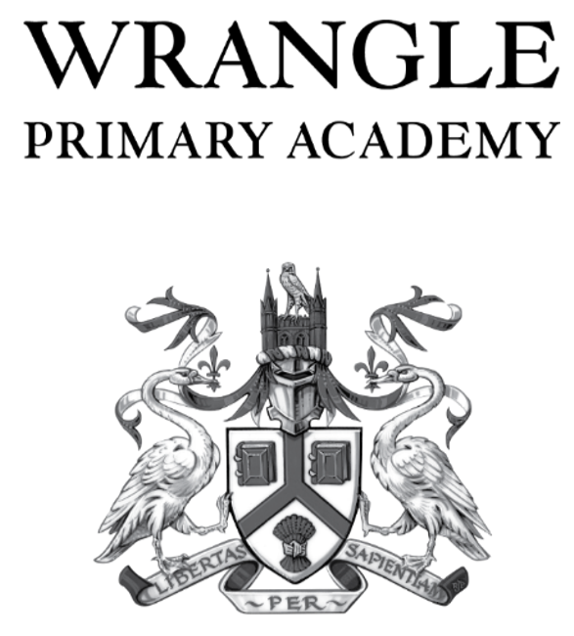
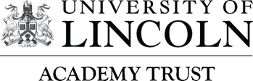

Email: enquiries@wpacademy.uk Wrangle Primary Academy
Website: www.wrangleprimaryacademy.co.uk Main Road
Wrangle
Boston
Lincs PE22 9AS
Tel. 01205 870509
Principal: Mrs T Hebron

15th May 2026

Dear Parent/Carers

Upcoming Changes to Relationships and Sex Education (RSE) – Consultation for September 2026

We are writing to inform you about upcoming updates to our Relationships and Sex Education (RSE) curriculum, which will take effect from September 2026. These amendments follow the most recent national guidance and reflect our continued commitment to providing pupils with age-appropriate, inclusive and high-quality learning that supports their wellbeing and personal development.

What is changing?

The updated RSE content will include:

- Revised learning objectives to reflect new statutory guidance.
- Updated lessons on healthy relationships, personal safety and digital citizenship.
- Additional age-appropriate content designed to help pupils navigate key stages of growing up with confidence and understanding.
- Clearer progression across year groups to ensure continuity and consistency.

Our aim remains to equip pupils with the knowledge and skills they need to stay safe, respect others and make informed, responsible choices.

Parent Consultation

As part of our review, we would like to invite you to take part in a consultation so that your views can help shape the final curriculum. We value your input and want to work in partnership to ensure that the programme reflects both statutory requirements and the needs of our school community.

How to participate:

- Consultation period: 15/5/2026 until 12/6/2026

- Parent information session: 12/6/2026 from 3.45pm until 4.45pm at Wrangle Primary Academy (adults only)

- Share your views: You can complete our consultation form which is attached to this letter.

During the information session, we will share an overview of the proposed curriculum, examples of teaching materials and details of how sensitive content will be taught in an age-appropriate manner. There will also be an opportunity to ask questions.

Next Steps

Once the consultation period closes, we will review all feedback and finalise the RSE policy and curriculum map. The finalised documents will be shared before they are implemented in September 2026.

We appreciate your continued support and look forward to hearing your views. If you have any questions in the meantime, please do not hesitate to contact me.

Yours sincerely

Mrs Tiffany Hebron
Principal

