Willow Class Home Learning
This term we will be learning all about The Vikings and if they were they raiders, traders or settlers? Below are some tasks linked to our learning. Bring in any completed work or photographs to share.
Design a Viking Shield  Use colours and symbols to create your own shield. Think about what your design represents.  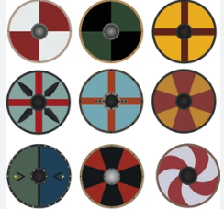 | Research Viking Runes – can you write your name  ᚹᛁᛚᛚᛟᚹ ᚲᛚᚨᛋᛋ  What does this say? | 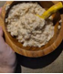  Enjoy a Viking breakfast of Grautr (Oat Porridge): A staple Viking breakfast. With an Adults help. Simmer oats in water or milk, and top with a generous drizzle of honey, chopped nuts, and wild berries.
Write a list with commas of what you would take with you to sea on a longboat.  When I went to sea with the Vikings I took…. | Enjoy reading with or to an adult every night for 10 minutes.  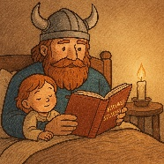 | 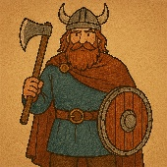  Can you Dress as a Viking and take a photograph for our Display
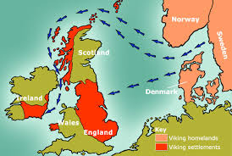  Can you find where the Vikings came from on a Map? | 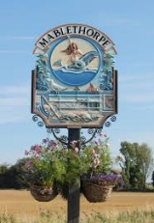  Place Names Hunt  Find local place names ending in -by, -thorpe or -ham and research what they mean. | Draw a Vilking longboat and label the parts  